1. **Analyze the request** [**https://www.makeup.com.ua/**](https://www.makeup.com.ua/)**, method and status**

**Browser - Google Chrome**

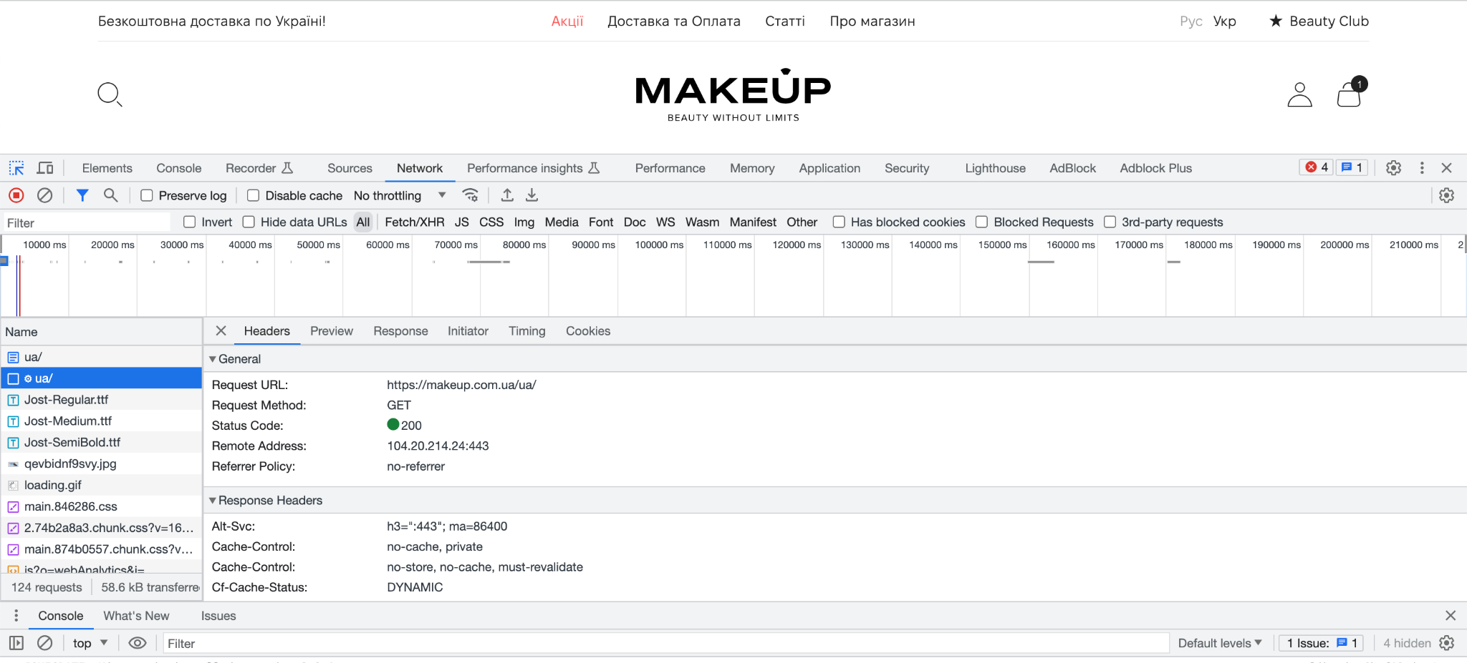

Status - 200. The HTTP response code indicates that the request was successfully completed.

Method - GET. The HTTP GET method requests a representation of the specified resource. Requests using GET should only be used to request data (they shouldn't include data).

1. **Analyze the request** [**https://makeup.com.ua/**](https://makeup.com.ua/) **, method and status**

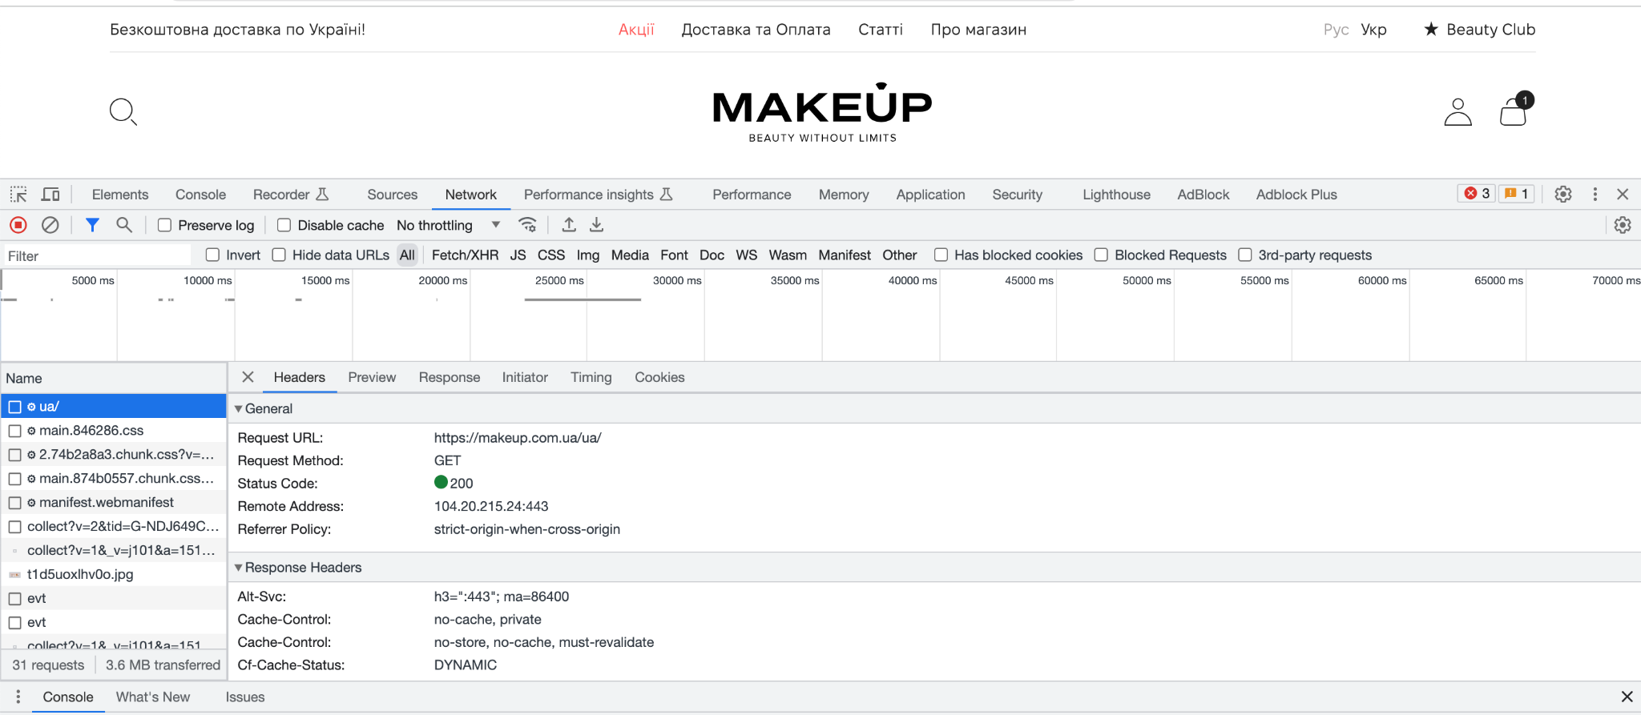

Status - 200. Method - GET.

**3. Add any product to the cart and analyze the cart request, method and status**

Add the product to the cart, continue shopping, and then click on the Cart icon, in the right corner of the site - go to the product in the cart:

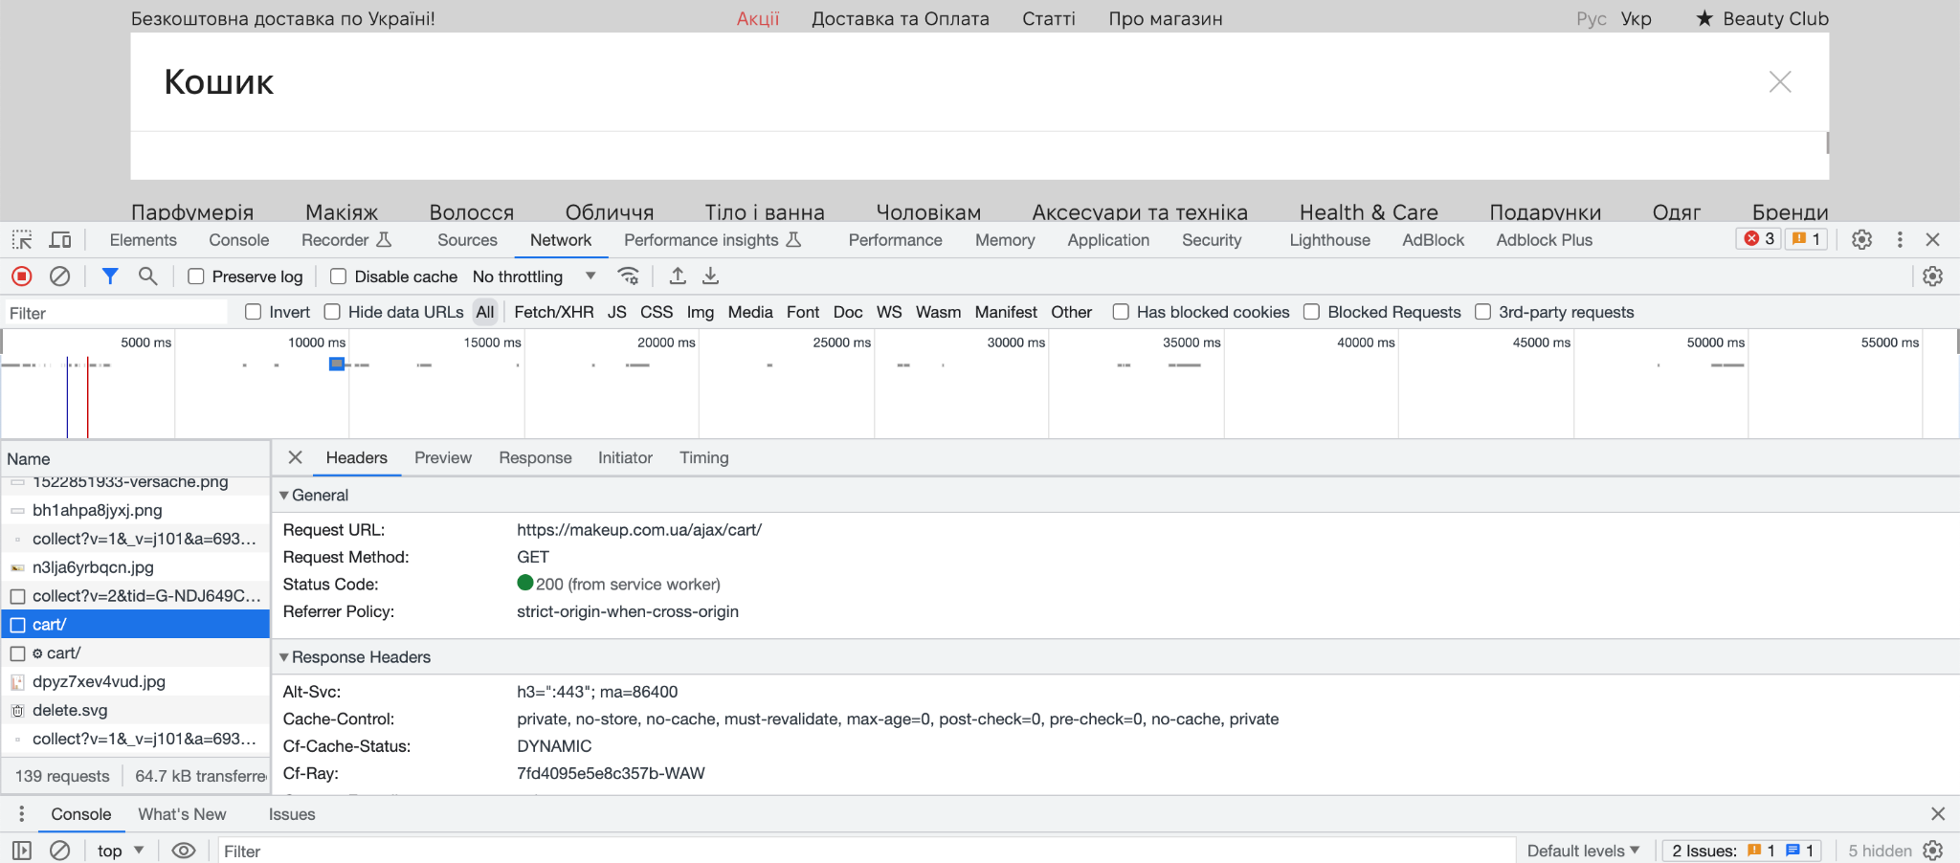

Status - 200. Method - GET.

Adding a product to the cart:

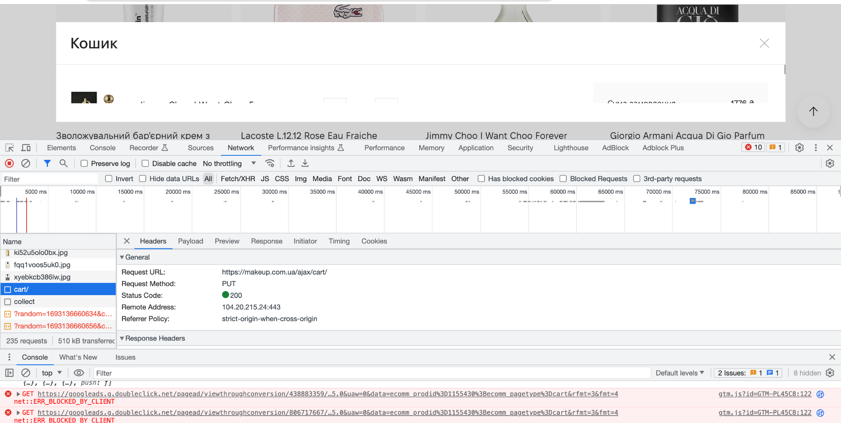

Status - 200. Method - PUT. The PUT method replaces all current representations of the target resource with the request payload.

Removing the product from the cart:

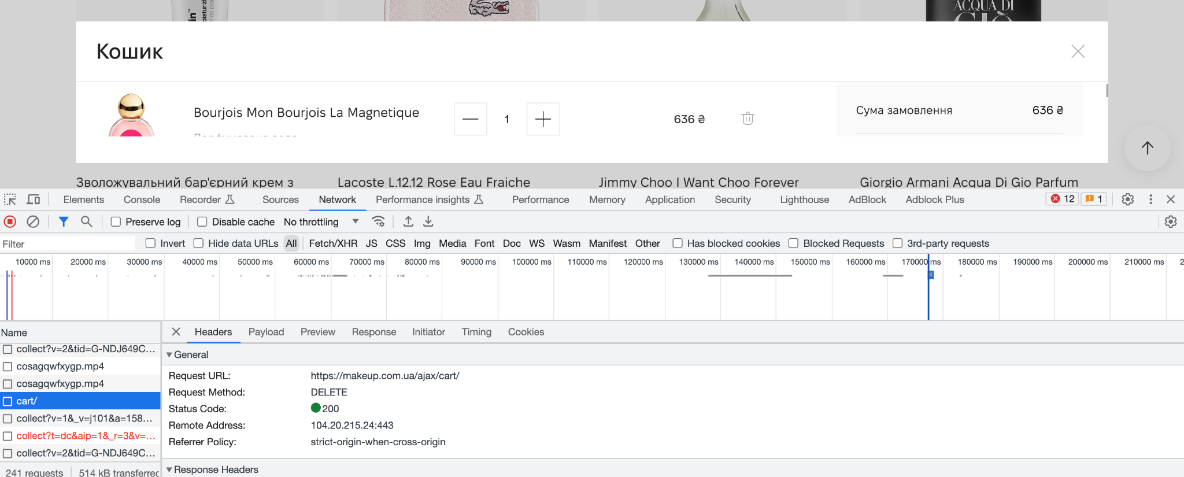

Status - 200. Method - DELETE. The DELETE method deletes the specified resource.

**4. Enter** [**https://www.makeup.ua/**](https://www.makeup.ua/) **in the address bar to analyze the request and status.**

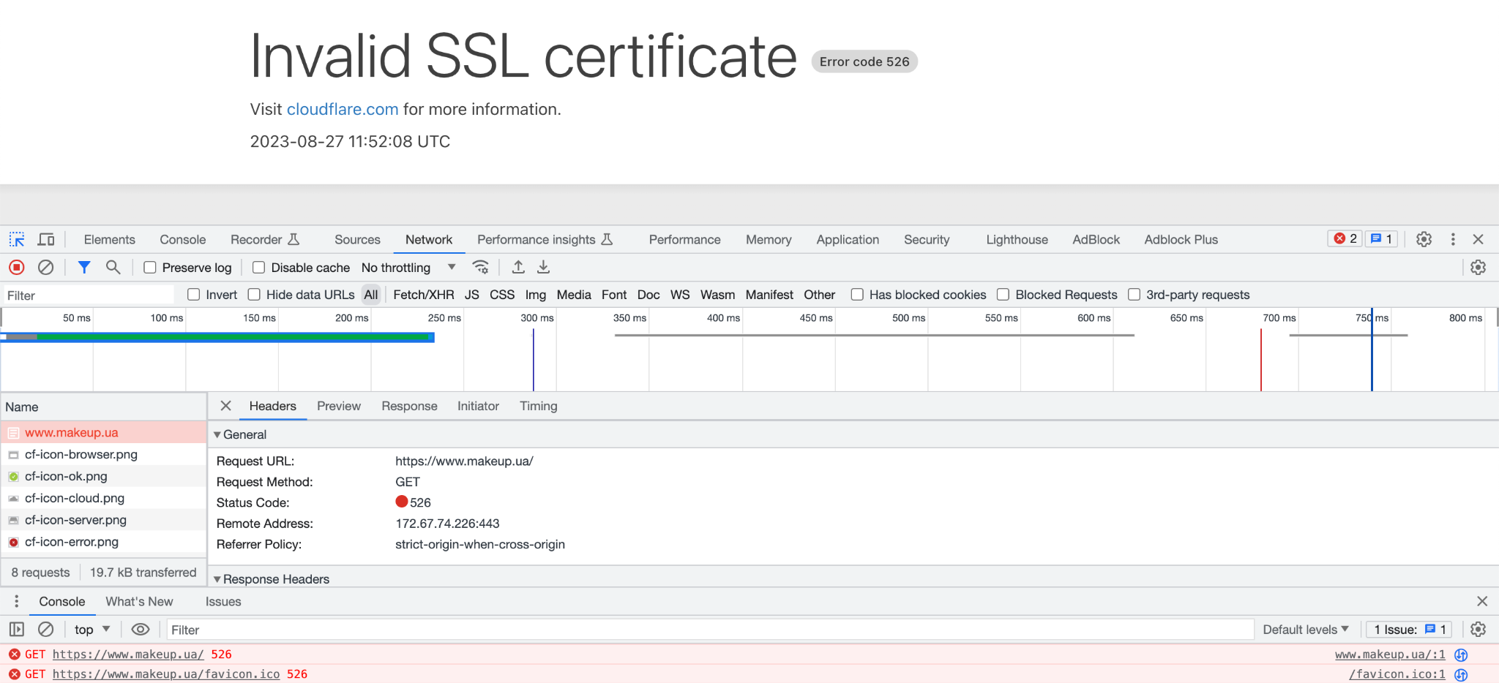

Error code 526. Server error. Error 526 is one of the most significant errors when a web server fails to connect with a website securely. When a browser detects an invalid SSL certificate sent by a website server, a secure connection is difficult, causing the error.